Dear Patient.
I would like to take this opportunity to thank you for your continued support. General practice is the busiest it has ever been in the 42 years I have been in this practice. It can be difficult in all areas as we try to deliver the best care we can. There have been many changes over the last few years with retirements, covid and recruitment of new staff clinical and non-clinical. I think its safe to say that we are now on track. We have a new Partnership who have the passion to deliver the best care for our practice population. This has taken time to build up over the last year or so.
Our Clinical Team
- Dr Stephen Brady Senior Partner
- Dr Gemma Fitzpatrick Partner
- Dr Sumayya Nowrin Partner
- Dr Reshikesh Kandy Salaried Partner
- Lisa Jackson Advanced Healthcare Practitioner
- Kamran Khalid Advanced Healthcare Practitioner
- Karen Brady Practice Nurse
- Claire Farrell Practice Nurse/ Advanced Healthcare Practitioner
- Susan Bradshaw Assistant Practitioner
- Natalie Davies Trainee Healthcare Support worker
Primary Care Network
We work closely with other practices in Middleton as part of Middleton Primary care Network to enable all practices to access other services for our patients from other healthcare professional. The Network Partnership is growing and will be an asset to our practice population
Primary Care Network Healthcare Professionals
- Paramedics- who will see patients acutely unwell in our practice
- Social Prescriber Link Workers- who can signpost and support patients with their needs such as, housing, benefits, financial issues, bereavement and more
- Mental Health Practitioners
- Psychologist
- Phlebotomy
- Clinical Pharmacist
What’s going on behind the scenes?
Telephones
- We really appreciate how difficult it can be to get through on our telephone system. There are reasons for this. We actively try to help patients ringing in with questions, problems etc- all of this can take time with each call, doing this inevitably creates a backlog of calls. Patients are advised to avoid telephoning for non-urgent problems between peak periods.
- We have seen an increase in patients choosing to come to the surgery early mornings, this is something we would not really encourage and hope that the following will ease the telephone traffic

Telephone Traffic

What have we done about this?

- We have looked to improve the telephone system and should be upgraded very soon
- We have taken on new reception staff who have been recently training to help support the telephone traffic
- We are encouraging patients not to use the main telephone line to order repeat prescription
- We have an answerphone facility which is open 24/7 to order repeat medication Telephone Number 0161 643 9431
- Created a designated email address- Email your request to hmrccg.woodside@nhs.net
- Patients can register for online services to order repeat Medication
- Introduced patients to Patchs our non-urgent e-consultation service for medication and non-urgent questions, sick notes renewals etc. see our website for more information
Appointment Access
General practice is changing locally and nationally, patients do not always need an appointment with a GP in the practice as the other Healthcare Professionals listed above are more than qualified to meet the needs of patients just like the GP can. They have undertaken training and academic qualifications to be able to examine, assess, make diagnoses, treat, prescribe, and make referrals for patients who present with undiagnosed/undifferentiated problems. This enhances access to appointment to meet the demands in general practice.
Nursing Staff
We have increased capacity to meet the demands of caring for our practice population in terms of preventative Medicine, a few for example include:
- Condition reviews – such as asthma, diabetes, etc
- Child and Adult Immunisation
- Cytology (cervical smear test)
- Contraception
- NHS Checks
- Flu Vaccines/ Covid Vaccines
- Cancer Care
- Mental Health
- And more
Celebrations
In November 2022 the practice will be 61, Like me lots of you will have seen many changes over the years with the retirements of Dr Thompson, Dr Glover, Dr Peck and Dr Libbert all of whom are no longer with us (RIP) The 4 GP’s served the patients on Langley estate for many years. They came together to form a Partnership of 4 in 1961 named the “Langley Group Practice”.
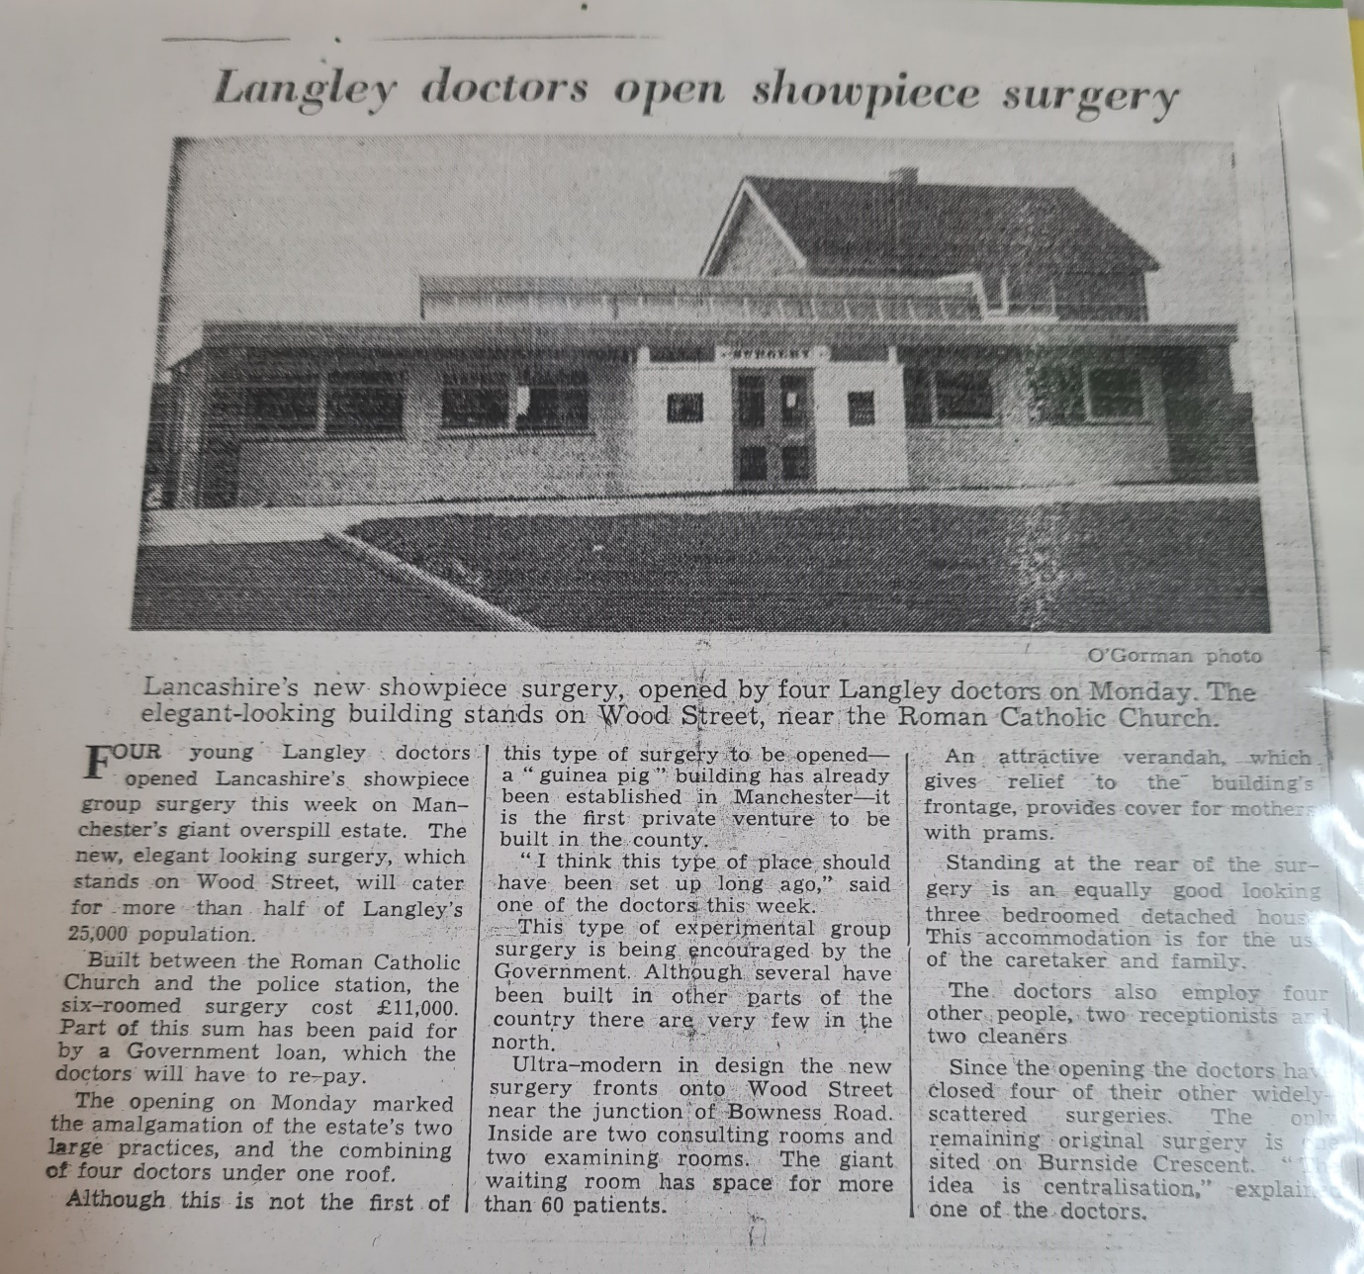

Some of you will have seen Dr Manchester, Dr Maynard, Dr Hyman, Dr Brady, Dr Vidya Join the practice over the years. Then In 1997 after several months in portacabins in the grounds of Langley Clinic a new purpose-built practice was finally finished in December 1997 with a change of Name too.

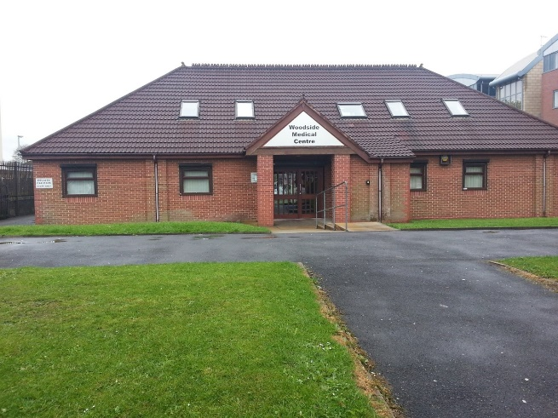
Over the last years we have seen the retirements of Dr Hyman, Dr Maynard, Dr Vidya, Dr Manchester and wish them all a long happy retirement after their many years of service.
We welcome our New Partners and Healthcare Professionals working alongside Dr Brady now senior partner. Our aim is to provide the best care that we possibly to patients at Woodside Medical Centre.
Thank you for your patience and continued Support. I hope that you can work with us as we moved forward into the next generation.
Please see attached information for you to help the practice move forward in terms of access to the practice

Tina Bennion
Practice Manager
Supporting information
As you will be aware public satisfaction with general practice remains high, but increasingly, patients are reporting more difficulty in accessing services. Practices would like to offer better access, but that they are experiencing increasing pressure and are having difficulties in offering their patients timely appointments.
Sometimes the best professional to deal with your needs is not the GP. Receptionist will ask you 3 questions that will assist them to make sure you see the most appropriate person in the shortest possible time. The questions will cover:

- Nature of the problem?
- Duration of the problem?
- Severity of the problem?
Please help the receptionist to help you by answering the questions
Care Navigation and signposting
As mentioned above, when you contact the practice you will be asked some questions by the receptionist/care navigator who will have had specialist training. This helps to ensure that you see the right professional for your needs, which is not always the GP. Please be assured that if you need to speak the GP you will still speak to the GP. We ask for your support and patience whilst this takes place. Hopefully you will then begin to see improvements to how you access primary care services for the future.
All requests for urgent appointments on the day will be reviewed by the Practice for appropriateness. This will result in fewer inappropriate GP appointments and better use of the surgery Nursing Team and other Healthcare professionals and services, such as pharmacists and opticians. A local survey of GP appointments found that 20 – 25% of appointments would have been better dealt with by another healthcare professional / NHS service.
The aim is to ensure that patients are seen quickly and efficiently by the most appropriate person, dependant on the individual problem.
Did not Attend an appointment (DNA)
Appointments that could have been rebooked for another patient. Please support your GP Practice by contacting the surgery if you are unable to keep an appointment. This may be hard if phones are busy, the text system used by the practice to remind patients of their appointments has an option to inform whether you can attend or not.

Telephone Traffic

We are encouraging patients not to use the main telephone line to order repeat prescription
We have an answerphone facility which is open 24/7 to order repeat medication Telephone Number 0161 643 9431
Designated email address- Email your request to hmrccg.woodside@nhs.net
Patients can register for online services to order repeat Medication
Introduced patients to Patchs our non-urgent e-consultation service for medication and non-urgent questions, sick notes renewals etc. see our website for more information

Patchs
PATCHS is an “non urgent” online consultation service that allows you to quickly and easily access GP services.
Answer 4 simple questions and PATCHS will get you the help you need.

How it works
Patients answer four simple free text questions, covering the details of their request
This enables the GP practice to quickly and safely understand how best to respond.
You can register for PATCHS via practice website.
www.woodsidemedicalcetre.co.uk
You’ll be asked to enter your email address and set a password.
Once you have registered, you can access PATCHS by clicking the link on your GP website or opening the PATCHS app on your smartphone. Login by entering your registered email address & password.
Choose the appropriate option and answer a few simple questions to help your GP understand your problem.
Test Results
Patients are reminded to contact the practice for all test/investigation results If you have had an investigation/ blood test etc- Please ensure that you call after 3pm Monday- Friday

Minor Eye Problems?
If you have a recent problem with your eyes – such as sore eyes, red eyes or visual disturbance – you can be assessed and treated by our local Minor Eye Conditions Service. This is a free NHS service available from a number of local opticians. On this page you can find information about what conditions are covered by the service and how to book an appointment. What is the Minor Eye Conditions Service (MECS)?
Conditions that can be seen under the service include:
- Red eye or eyelids
- Dry eye, or gritty and uncomfortable eyes
- Irritation and inflammation of the eye
- Significant recent sticky discharge from the eye or watery eye
- Recently occurring flashes or floaters
- In growing eyelashes
- Recent and sudden loss of vision
- Foreign body in the eye
Please note, this is not a sight test
Also, if you have a major eye condition that is being regularly monitored by your optometrist or hospital eye service, this will not be covered by this service; for example, cataracts, diabetic retinopathy or glaucoma.

Who is this service for?
If you are registered with a local GP you can use this free service. It is for people of all ages – adults and children. Children under 16 years must be accompanied at their appointment by an adult.
The service is offered by local opticians at locations across Heywood, Middleton and Rochdale. Appointments are available during normal working hours and some practices offer appointment at weekends. Not all practices have an optometrist available every day, but if they don’t, they will be able to find you an alternative appointment nearby.
Boots Opticians
0161 655 3021
D Igoe Opticians
0161 653 0771
Specsavers Opticians
0161 654 0440
Please note: this is not a walk-in service and patients require an appointment

