 **7 Day Access to a GP or Nurse**

**GP surgeries are now ‘there for you’ in the evening, weekend and bank holiday**

The service has been introduced to give patients more flexibility in where, when and how they use local health services. It has been designed to help those who find it hard to get to the doctors during the week, perhaps because of work and family commitments.

While patients may not get to see their own doctor during these hours, the GP or nurse they do see will have access to the patient’s medical record, subject to their consent.

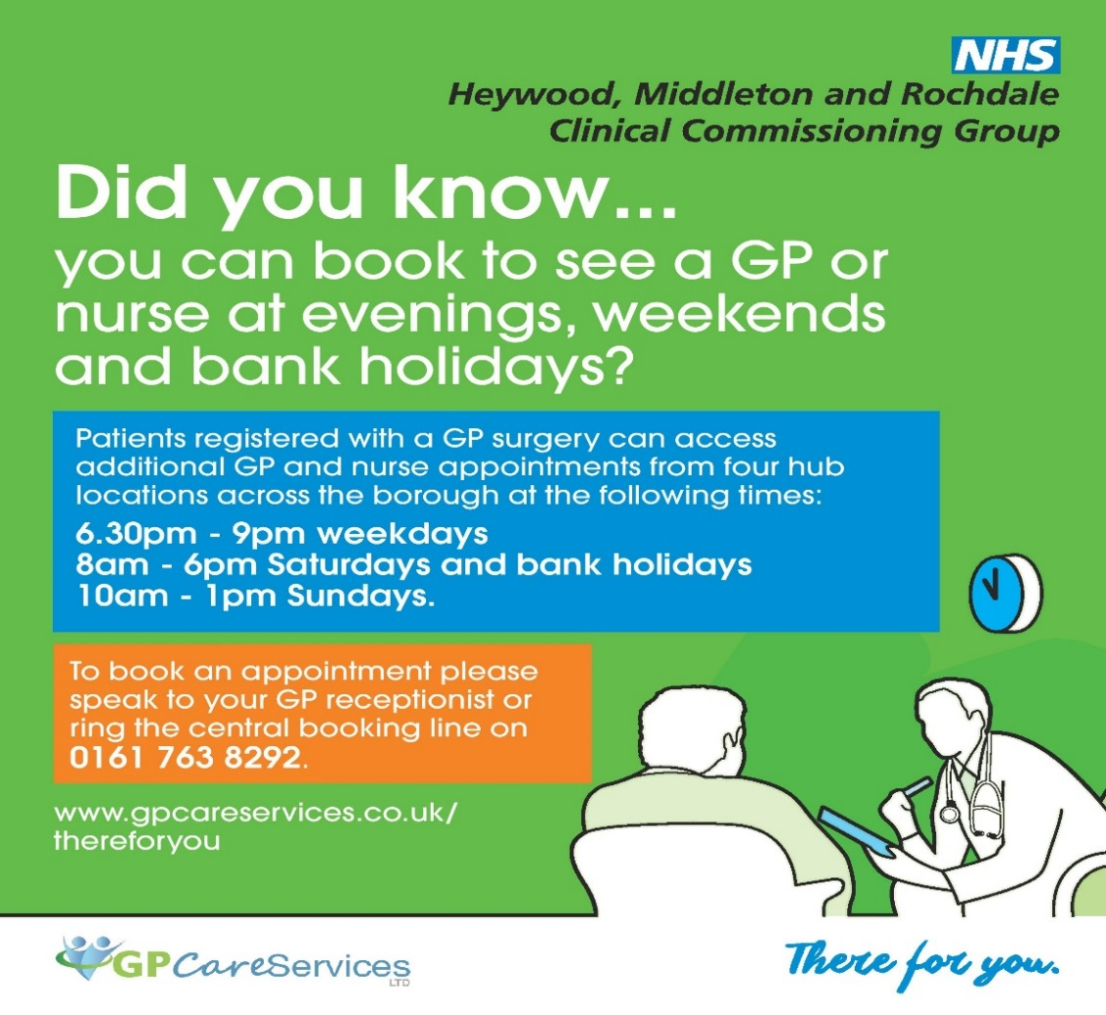

 **IMPROVING ACCESS TO GP SERVICES**

As you will be aware public satisfaction with general practice remains high, but increasingly, patients are reporting more difficulty in accessing services. Practices would like to offer better access, but that they are experiencing growing pressure and are having difficulties in offering their patients timely appointments.

To help address these problems, Heywood, Middleton and Rochdale Clinical Commissioning Group have developed an ‘Improving access to general practice scheme’ which requires practices, working in partnership, with Rochdale Health Alliance, the local GP Federation, to implement some changes which are intended to improve access.

Sometimes the best professional to deal with your needs is not the GP. The main change that you will experience is that the receptionist will ask you 3 questions that will assist them to make sure you see the most appropriate person in the shortest possible time. The questions will cover:

* **Nature of the problem**?
* **Duration of the problem**?
* **Severity of the problem**?

Please help the receptionist to help you by answering the questions.



**Care Navigation / Sign Posting**

As mentioned above, when you contact the practice you will be asked some questions by the receptionist/care navigator who will have had specialist training. This helps to ensure that you see the right professional for your needs, which is not always the GP. **Please be assured that if you need to see the GP you will still see the GP**. There may be a settling in period for this new service, we ask for your support and patience whilst this takes place. Hopefully you will then begin to see improvements to how you access primary care services for the future.



**Managing the Demand**

All requests for urgent appointments on the day will be reviewed by the Practice for appropriateness.

This will result in fewer inappropriate GP appointments and better use of the surgery Nursing Team and other Healthcare professionals and services, such as pharmacists and opticians. A local survey of GP appointments found that 20 – 25% of appointments would have been better dealt with by another healthcare professional / NHS service.

**The aim is to ensure that patients are seen quickly and efficiently by the most appropriate person, dependant on the individual problem.**

If you need to see a GP you will see a GP



**Patient on Line Services**

Many patients already use the on line services available for their GP Practice

GP online services allow you to access a range of services via your computer or mobile. Once you have signed up, you will be able to:

* book or cancel appointments online with a GP or nurse
* renew or order repeat prescriptions online
* view parts of your GP health record, including information about medication, allergies, vaccinations, previous illnesses and test results

If you have not tried these services then please ask the receptionist at your GP Practice, where they will be happy to register and guide you through these options

**Reducing DNA (Did Not Attend) Appointments**



Each DNA is an appointment that could have been rebooked for another patient. Please support your GP Practice by contacting the surgery if you are unable to keep an appointment. This may be hard if phones are busy, but we are implementing new avenues which may help. The text system used by practices to remind patients of their appointments has an option to inform whether you can attend or not.



**Practice opening times**

From October 2017, all practices across Heywood, Middleton and Rochdale will be open from 8.00am to 6.30pm and will have their telephone lines on.

This means that appointment requests can be made from 8.00 in the morning or that patients could call in on their way to and from work to pick up a prescription or book an appointment. Please note that surgery consultation times are not changing, this is about patients being able to access the practice during those hours.